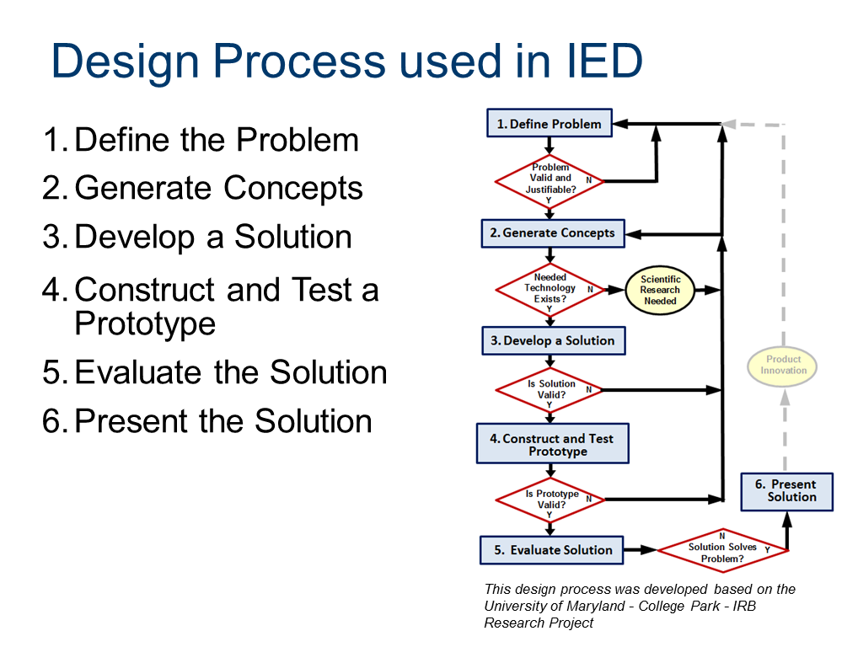
Truss Bridge- Design Challenge
Problem Description:
You are part of a team of engineers who have been given the challenge to design a bridge out of Popsicle sticks and wood glue. Students must use a truss configuration in the design of their bridge. Bridges will be tested until failure. While the number of Popsicle sticks is not limited, the goal is to create the most efficient design (holding the most weight, using the lease amount of material). In addition to creating the most structurally efficient design, the bridge will be judged on its aesthetics as well, so be creative! Don’t forget, you are encouraged to use the fewest number of popsicles possible to achieve your goal.

You must follow and document each of the steps of the Engineering Design Process to develop your solution.
Design Criteria & Constraints:
Dimensions:
- Must be constructed using wooden craft sticks (113 mm by 10 mm) and wood glue
- The bridge must be self-supporting with a clear span of 600mm
- Each end of the bridge must extend at least 50 mm and note more than 75 mm beyond the edge of the platform on which it will be supported. Therefore, the bridge must be at least 700 mm long and cannot be longer than 750 mm.
- The bridge structure must be no taller than 150 mm.
- Total width of the bridge shall provide for a minimum 80 mm wide roadway. The total bridge with chall be no wider than a maximum of 125 mm.
- The roadway must be locate within the structure and must be a minimum of 80mm wide and 100 mm high. These minimum dimensions must extend continuously throughout the entire length of the structure and cannot be penetrated by any structural bridge members. The roadway must be flat. Sticks are not required to represent the roadway along the bottom of the structure.
Construction:
- Bridge numbers cannot be continuously glued or laminated together along the entire length of adjacent members (flat or on edge).
- Parallel craft sticks with appropriately located spacers glued in place are permitted.
- Parallel craft sticks cannot be aligned directly side0byside or edge-to edge, such that the continuous glued or laminated rules cannot be easily verified.
- Gluing of members shall be limited to a 25mm long area at each of the member or at other locations along the member where additional connections are made per the design.
- In the event that a compound joint with 3 or more connecting members, the gluing of the members shall not extend beyond 25mm on either side of the center of the joint.
- If spacers are used between members, spacer connections must be located a minimum of 25mm apart along the length of the member.
Do not begin construction until you have completely finished steps 1-4!
Procedure:
Create a PowerPoint to Document Each Step of the project as described below.
Slide 1: Title Slide- Project Name, Student Names, Class Name, School Name, Spring 2014
Step 1: Define the Problem:
Slide 2: Define the Problem Statement in your own words. List the Project Criteria and Constraints
Step 2: Generate Concepts:
Research and document truss configurations and designs.
Slide 3: Create a PowerPoint Slide that documents the following information-
Define the following:
- Truss 2. Compression 3. Tension 4. Gusset
Find an image of at least 6 different “truss configurations” include images in the slide and list source(s) beneath the image.
Brainstorm
Slide 4: Create 3 detailed and annotated sketches of 3 truss design ideas that could be used in your beam design. Show placement of gussets. (Make sure your final design will not take more than the 20 feet of material allowed and provided)
- Take an image of your sketches and add to your PowerPoint presentation
Select an Approach-
Slide 5: Create a decision matrix with 4 criteria to evaluate your 3 truss design ideas created during the brainstorming process. Be sure to include a scale and total the points to justify which solution you will create.
-Take an image (if hand drawn) or place a screenshot (if you use Excel) in your PowerPoint presentation.
Step 3: Develop Solution- Construction Drawings
Once you decide on a truss design, you will need to create drawings to document and plan your final design.
- Using 11 x 17 graph paper- create a 1:1 scale drawing of at least the top and side view of your box beam design (if the top and bottom are the same, and the sides are the same). If the views are different, create a drawing for it. Be sure that the two drawings line up so that your model will too (same length). Make sure the measurements and layout meet the project criteria and constraints. You will want to divide views between you and your partner (this way you can share building the model too). Annotate your drawing with measurements!
- Take your time creating your drawing. Neatness counts! If you take time now, it will make building the model easier.
- Make sure you show the thickness of the popsicle stick. Don’t just draw a line; show its width. Show each side.
Slide 6: Take an image of your drawings and add to your PowerPoint presentation (make sure it is very clear)
Step 4: Construct & Test Prototype
- Using the tools provided, you will construct the 4 sides of your truss bridge and assemble the four sides into a final bridge model.
Slide 6: Take images of each different side of your finished bridge model and place in your PowerPoint Presentation.
Construction techniques:
- Each member will get a piece of foam board. Tape your graph paper to the board and put a sheet of wax paper on top (so the glue will not stick). Build the side of your beam on top of this using your drawing as a guide. Be sure to put your name on your board so another student does not mistake it as their own.
- Use straight pins to securely hold the pieces of wood in place in order to construct it straight and true to the drawing. (Place the pins on the outside edges of the wood.
- Use wood glue at the joints. You can use smaller segments of the popsicle stick to create gussets at the joints; this will strengthen the connection.
- When cutting wood, use the saw or the blue handled clipers. You don’t want to snap or squeeze the wood to break it. Make sure the end is cut straight and is the correct length- not too short. You want it as accurate as possible. You want the wood to add strength; you don’t want to have to rely on the glue to fill a gap as this is weaker. A miter box will help ensure a straight cut.
- You can use a small emery board or fine sandpaper to sand the edge of a cut to make sure it is straight.
Testing Procedures:
- Efficiency Calculation
Efficiency (%)$=\frac{Weight held (g)}{Total Weight of Bridge (g)}$= _______________ x 100% =
The most efficient structure wins! In the event of a tie, the structure that holds the most weight overall wins. (Efficiency is rounded off to three (3) decimal places)
- The structure is weighed before testing and is recorded by the team
- A test block of wood will be placed on the top, center of the beam. The block will have an eye hook in which a bucket will be attached.
- Weight will be slowly added to the hanging bucket until failure. The failure weight will be recorded by the team.
- Failure will be determined by the class prior to the initiation of testing.
Step 5: Evaluate Solution
- Does the solution solve the problem? Does it function as designed? Were your results as expected?
Slide 7: In your PowerPoint presentation- list any modifications or improvements you would make based on your beam’s performance and calculated efficiency. This must consist of 4-5 sentences at minimum. Your responses will be evaluated based on thoughtful consideration of improvements based on test results. Be specific and detailed.
Step 6: Present Solution
-Complete and submit PowerPoint presentation. Submit the file to your Google Classroom Drive. Only 1 PowerPoint per team is needed

